***Objective* -:** Analyse the force on a charged particle in a uniform magnetic field and the path of motion of the particle in the region of magnetic field in both 2-D and 3-D.

***Theory* -:** The magnetic force on a charged particle is orthogonal to the magnetic field such that:

where B is the magnetic field vector, v is the velocity of the particle and θ is the angle between the magnetic field and the particle velocity. The direction of F can be easily determined by the use of the right-hand rule.

***Right-Hand Rule***

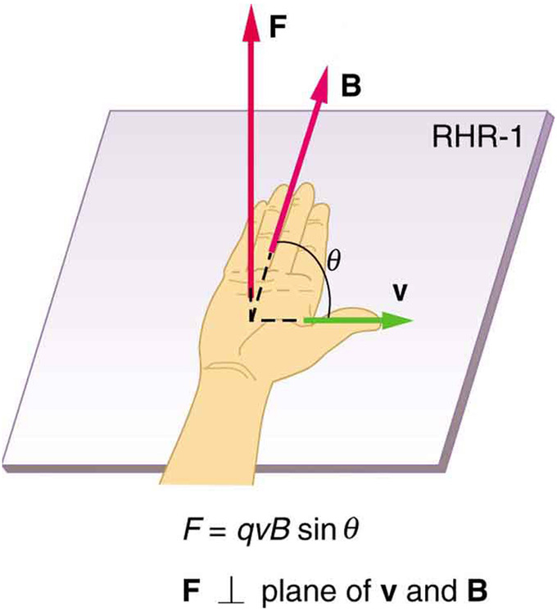Magnetic fields exert forces on moving charges. This force is one of the most basic known. The direction of the magnetic force on a moving charge is perpendicular to the plane formed by v and B and follows right hand rule–1 (RHR-1) as shown. The magnitude of the force is proportional to q, v, B, and the sine of the angle between v and B.

If the particle velocity happens to be aligned parallel to the magnetic field, or is zero, the magnetic force will be zero. This differs from the case of an electric field, where the particle velocity has no bearing, on any given instant, on the magnitude or direction of the electric force.

The angle dependence of the magnetic field also causes charged particles to move perpendicular to the magnetic field lines in a circular or helical fashion, while a particle in an electric field will move in a straight line along an electric field line.

A further difference between magnetic and electric forces is that magnetic fields does zero work, since the particle motion is circular and therefore ends up in the same place. We express this mathematically as:

The force a charged particle “feels” due to a magnetic field is dependent on the angle between the velocity vector and the magnetic field vector B. Recall that the magnetic force is:

If the magnetic field and the velocity are parallel (or antiparallel), then sinθ equals zero and there is no force. In this case a charged particle can continue with straight-line motion even in a strong magnetic field. If is between 0 and 90 degrees, then the component of v parallel to B remains unchanged.

***Special Cases:***

* ***When velocity is parallel to magnetic field***

In the case above the magnetic force is zero because the velocity is parallel to the magnetic field lines.

* 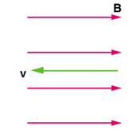 ***When velocity is perpendicular to magnetic field***

**Maximum force( F = qvB) when velocity is parallel to magnetic field.**

The magnetic force is always perpendicular to velocity, so that it does no work on the charged particle. The particle’s kinetic energy and speed thus remain constant. The direction of motion is affected but not the speed. If the field is in a vacuum, the magnetic field is the dominant factor determining the motion. Since the magnetic force is perpendicular to the direction of travel, a charged particle follows a curved path in a magnetic field. The particle continues to follow this curved path until it forms a complete circle.

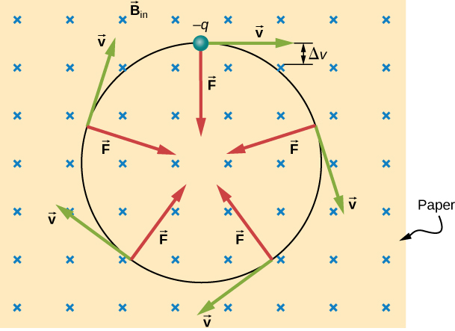

*In the figure: A negatively charged particle moves in the plane of the paper in a region where the magnetic field is perpendicular to the paper (represented by the small s—like the tails of arrows). The magnetic force is perpendicular to the velocity, so velocity changes in direction but not magnitude. The result is uniform circular motion.*

***Note that because the charge is negative, the force is opposite in direction to the prediction of the right-hand rule.***

In this situation, the magnetic force supplies the centripetal force. Noting that the velocity is perpendicular to the magnetic field, the magnitude of the magnetic force is reduced to . Because the magnetic force F supplies the centripetal force , we have

Here, r is the radius of curvature of the path of a charged particle with mass m and charge q, moving at a speed v that is perpendicular to a magnetic field of strength B. The time for the charged particle to go around the circular path is defined as the period, which is the same as the distance travelled (the circumference) divided by the speed. We can derive the period of motion as:

If the velocity is not perpendicular to the magnetic field, then we can compare each component of the velocity separately with the magnetic field. The component of the velocity perpendicular to the magnetic field produces a magnetic force perpendicular to both this velocity and the field:

where  is the angle between v and B. The component parallel to the magnetic field creates constant motion along the same direction as the magnetic field.

The parallel motion determines the pitch p of the helix, which is the distance between adjacent turns. This distance equals the parallel component of the velocity times the period:

The result is a **helical motion**, as shown in the following figure.

**helical motion**: The motion that is produced when one component of the velocity is constant in magnitude and direction (i.e., straight-line motion) while the other component is constant in speed but uniformly varies in direction (i.e., circular motion). It is the superposition of straight-line and circular motion.

Perpendicular component of velocity gives circular motion while the parallel component gives movement in the direction of field.

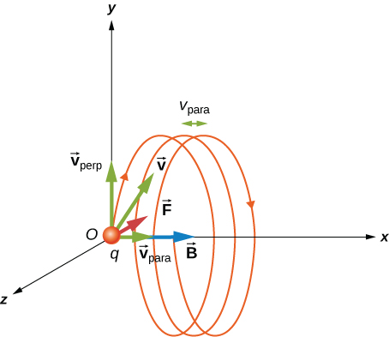

*In the figure: A charged particle moving with a velocity not in the same direction as the magnetic field. The velocity component perpendicular to the magnetic field creates circular motion, whereas the component of the velocity parallel to the field moves the particle along a straight line. The pitch is the horizontal distance between two consecutive circles. The resulting motion is helical.*

***Cyclotron***

A cyclotron is a type of particle accelerator in which charged particles accelerate outwards from the centre along a spiral path. The particles are held to a spiral trajectory by a static magnetic field and accelerated by a rapidly varying electric field.

***Observations* -:**

***Simulation 1*** -: Keeping the perpendicular component of velocity constant, magnetic field and charge constant and varying the mass of the particle.

**Snapshots** -:

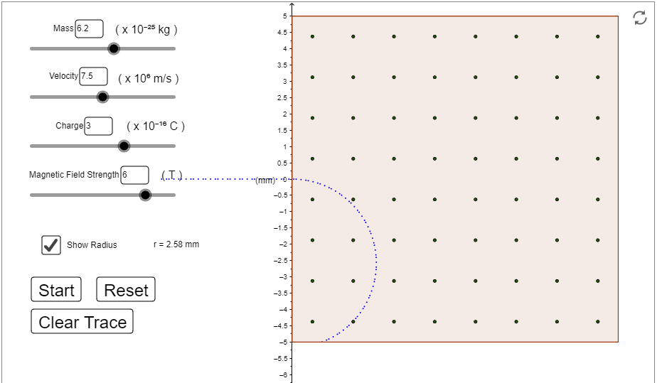

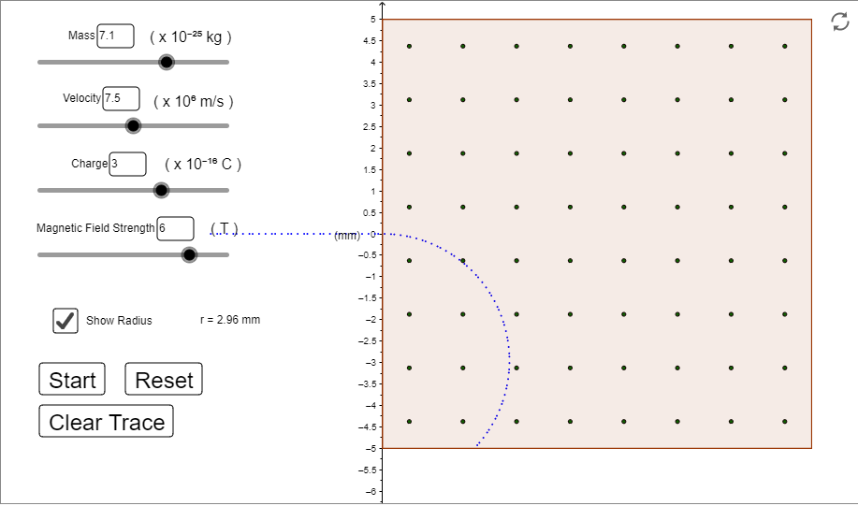

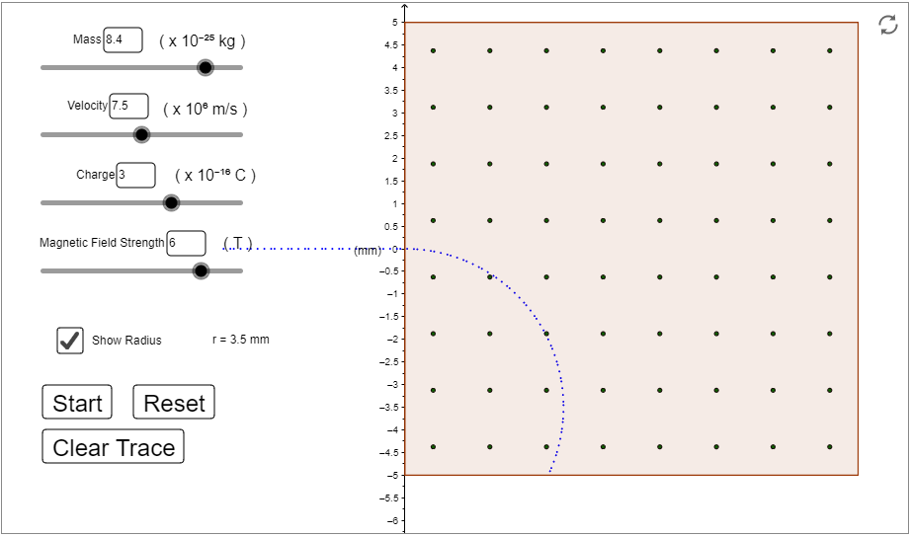

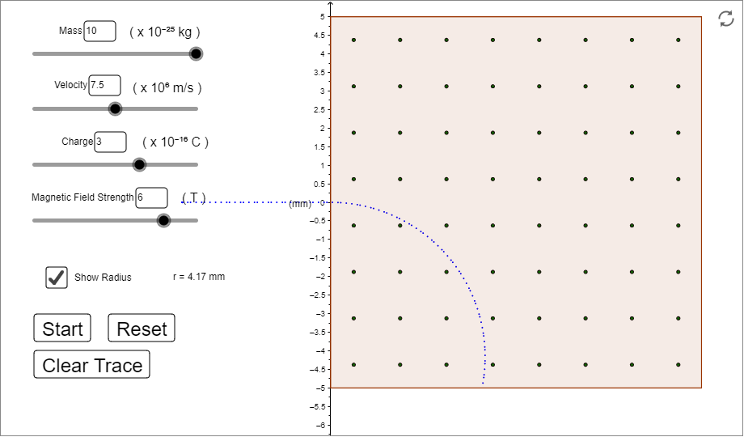

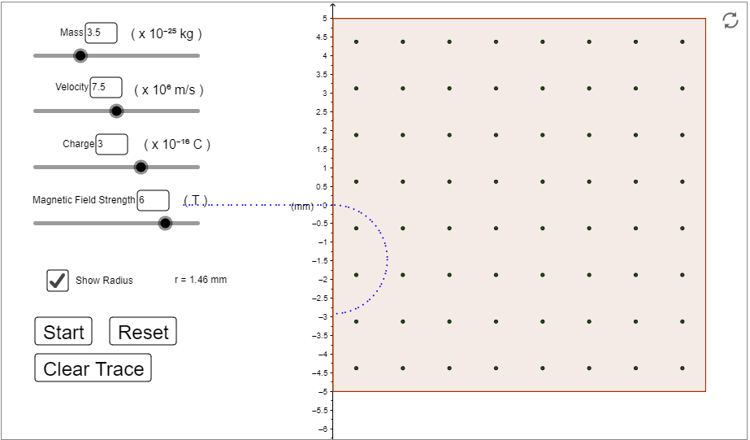

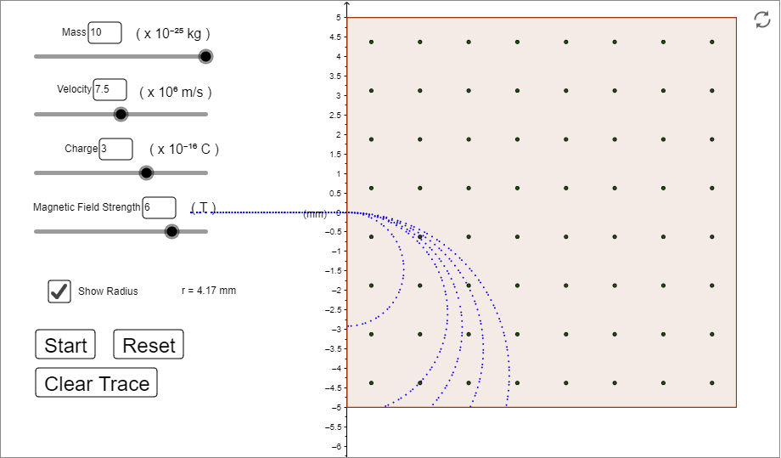

**Observation Table 1** -:

velocity =

charge =

magnetic field =

|  |  |  |  |  |
| --- | --- | --- | --- | --- |
| **S.No.** | **Mass** | **Radius**  **r =**  **(in mm)** | **Radius**  **observed**  **(in mm)** | **Time Period**  **(in nanoseconds)** |
| **1.** | 6.2 | 2.583 | 2.58 | 2.163 |
| **2.** | 7.1 | 2.958 | 2.96 | 2.477 |
| **3.** | 8.4 | 3.500 | 3.50 | 2.930 |
| **4.** | 10.0 | 4.166 | 4.17 | 3.488 |
| **5.** | 3.5 | 1.458 | 1.46 | 1.221 |

**Graph of radius(r) vs mass(m)** -:

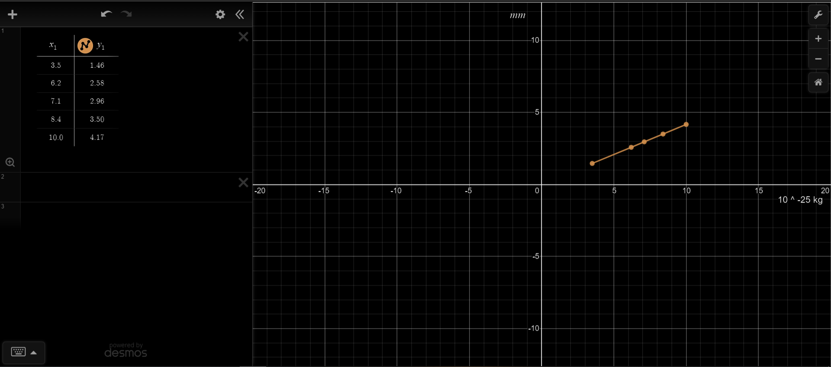

***Simulation 2*** -: Keeping the mass of the particle, magnetic field and charge constant and varying the perpendicular component of velocity.

**Snapshots** -: 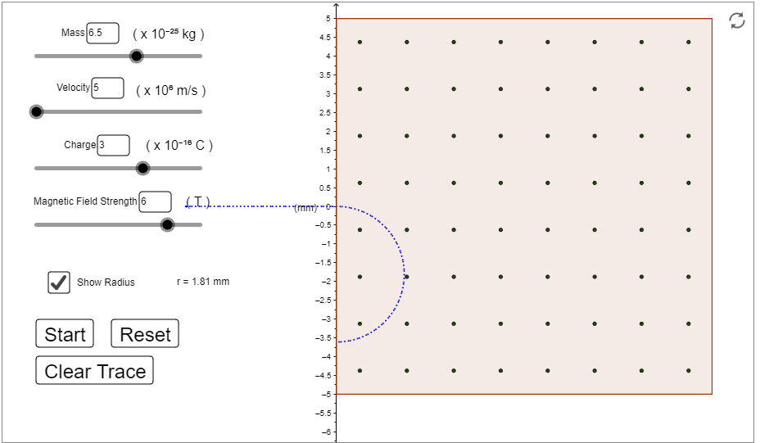

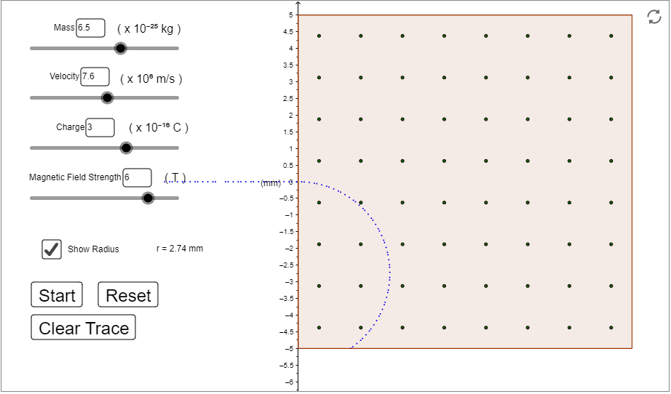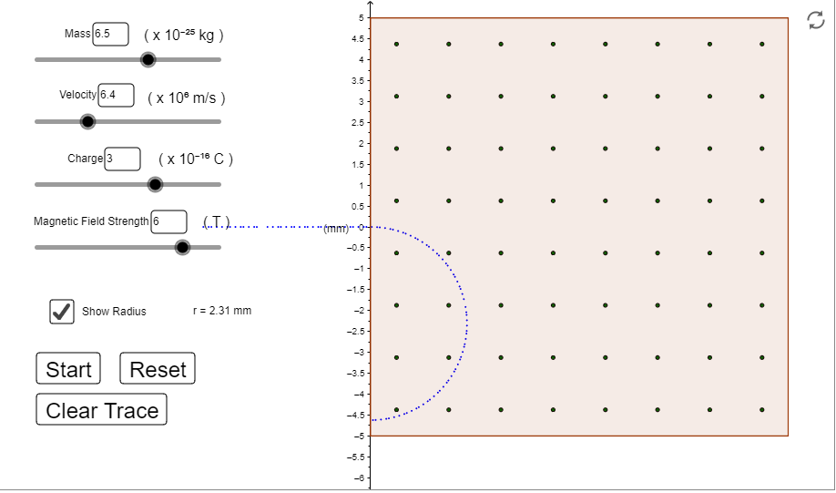

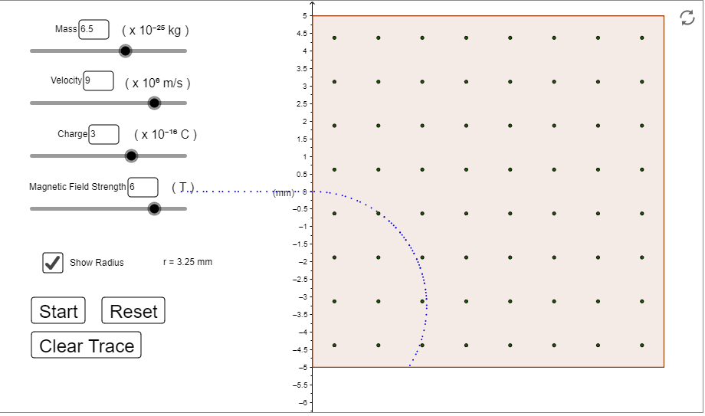

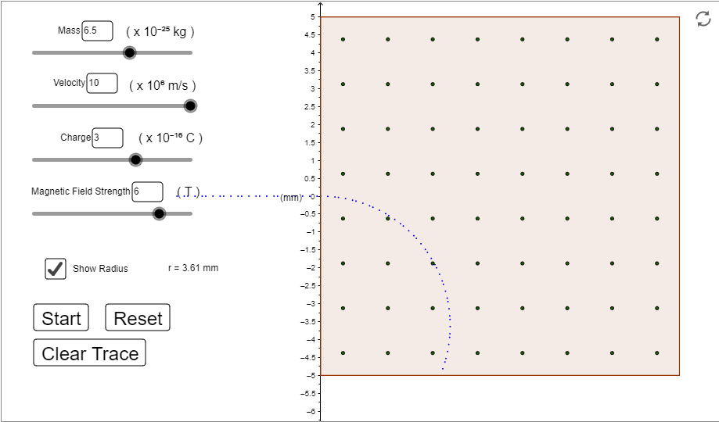

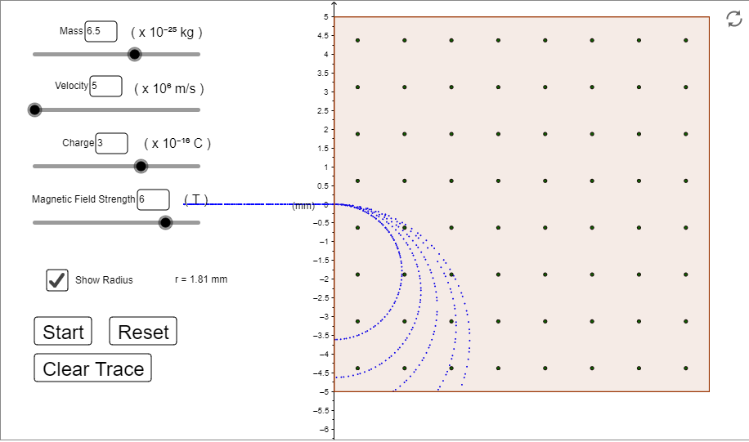

**Observation Table 2** -:

mass =

charge =

magnetic field =

|  |  |  |  |  |
| --- | --- | --- | --- | --- |
| **S.No.** | **Velocity** | **Radius**  **r =**  **(in mm)** | **Radius**  **observed**  **(in mm)** | **Time Period**  **(in nanoseconds)** |
| **1.** | 5.0 | 1.805 | 1.81 | 2.267 |
| **2.** | 6.4 | 2.311 | 2.31 | 2.267 |
| **3.** | 7.6 | 2.744 | 2.74 | 2.267 |
| **4.** | 9.0 | 3.250 | 3.25 | 2.267 |
| **5.** | 10.0 | 3.611 | 3.61 | 2.267 |

**Graph of radius(r) vs perpendicular component of velocity(v)** -:

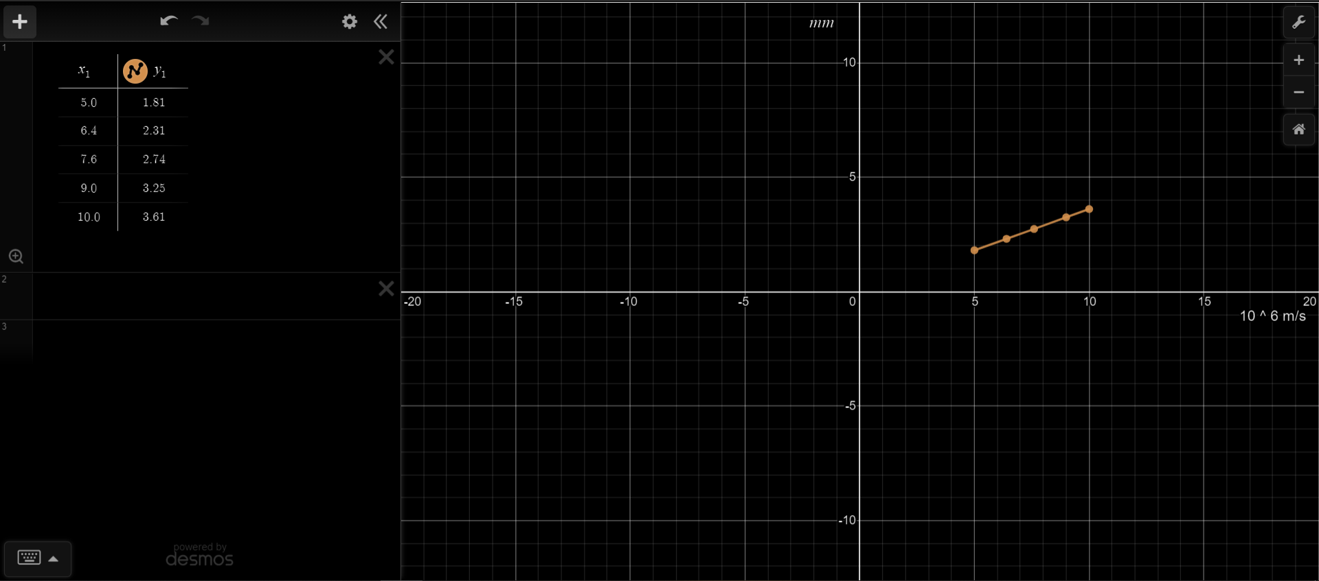

***Simulation 3*** -: Keeping the mass of the particle, perpendicular component of velocity and magnetic field constant and varying the charge.

**Snapshots** -:

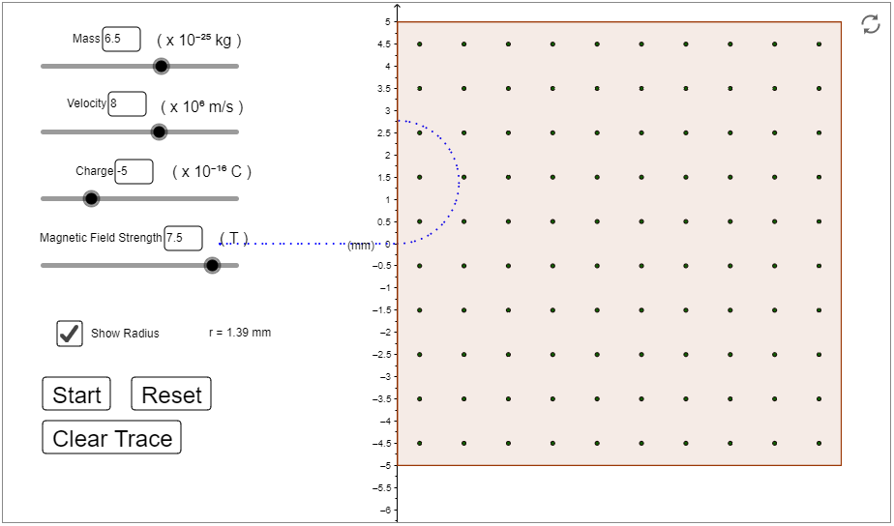

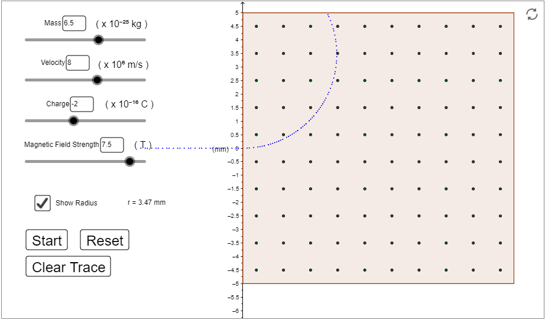

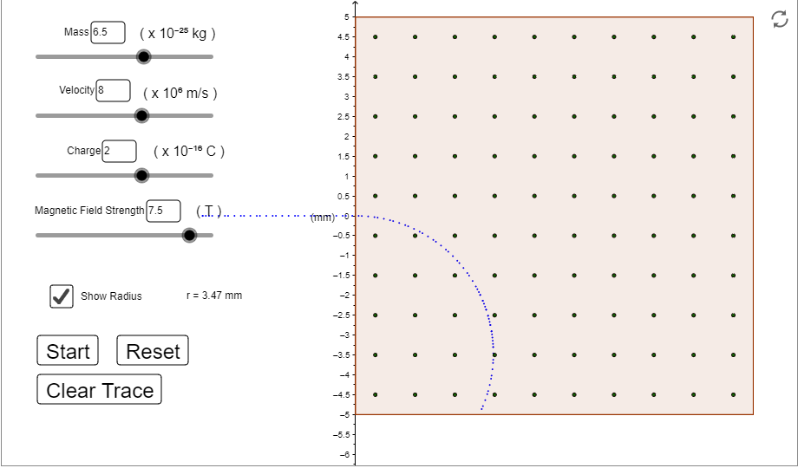

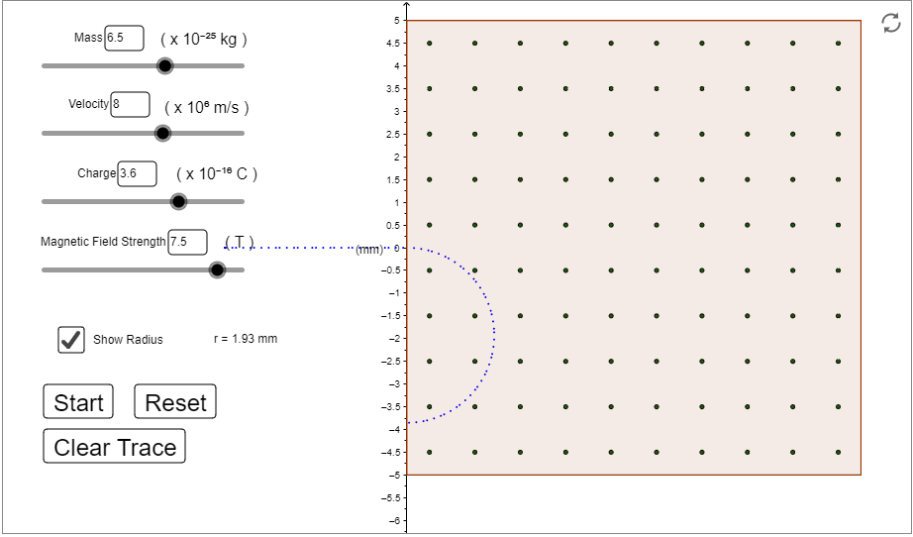

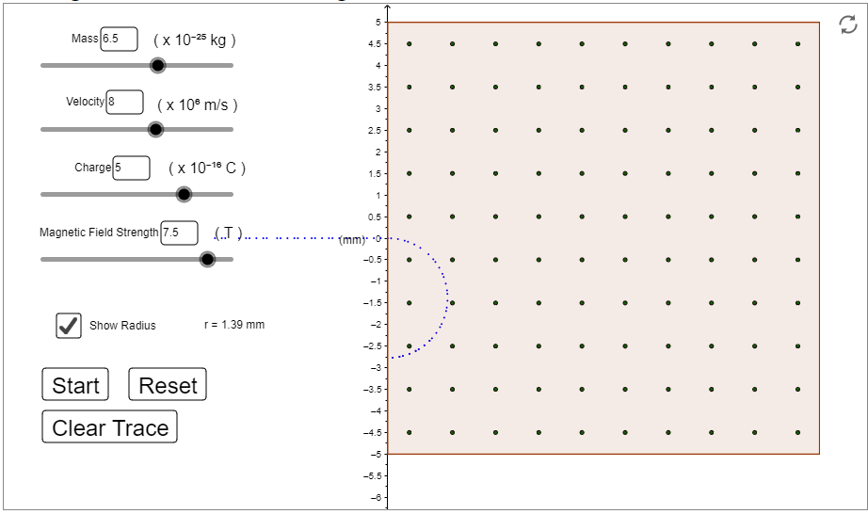

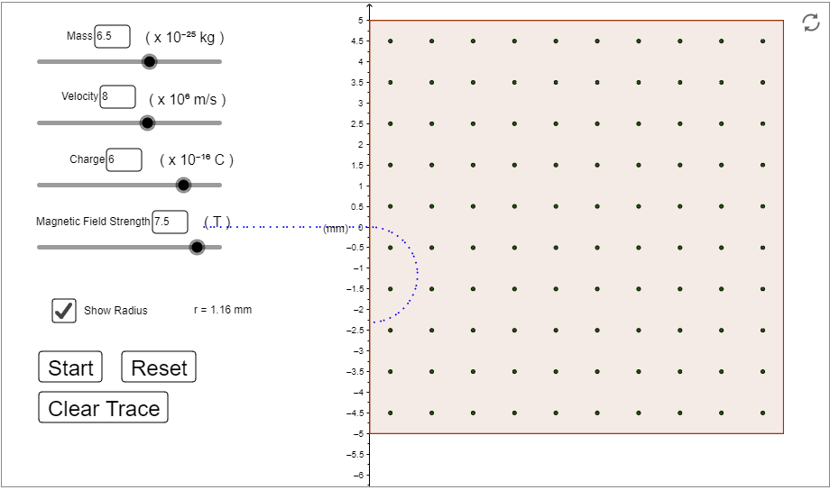

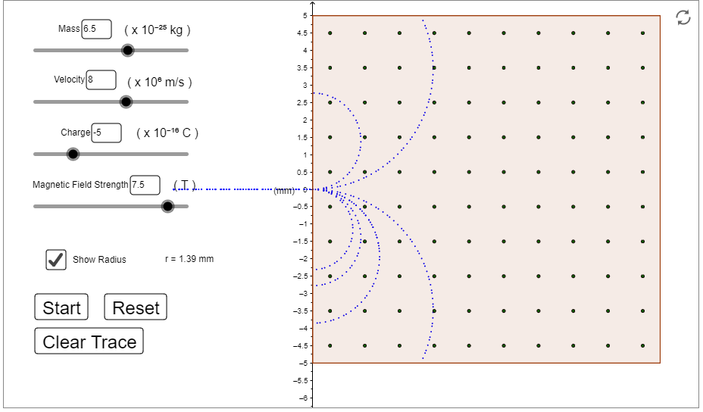

**Observation Table 3** -:

mass =

velocity =

magnetic field =

|  |  |  |  |  |
| --- | --- | --- | --- | --- |
| **S.No.** |  | **Radius**  **r =**  **(in mm)** | **Radius**  **observed**  **(in mm)** | **Time Period**  **(in nanoseconds)** |
| **1.** | -5 | 1.386 | 1.39 | 1.088 |
| **2.** | -2 | 3.466 | 3.47 | 2.721 |
| **3.** | 2 | 3.466 | 3.47 | 2.721 |
| **4.** | 3.6 | 1.926 | 1.93 | 1.512 |
| **5.** | 5 | 1.386 | 1.39 | 1.088 |
| **6.** | 6 | 1.155 | 1.16 | 0.907 |

**Graph of radius(r) vs charge(q)** -:

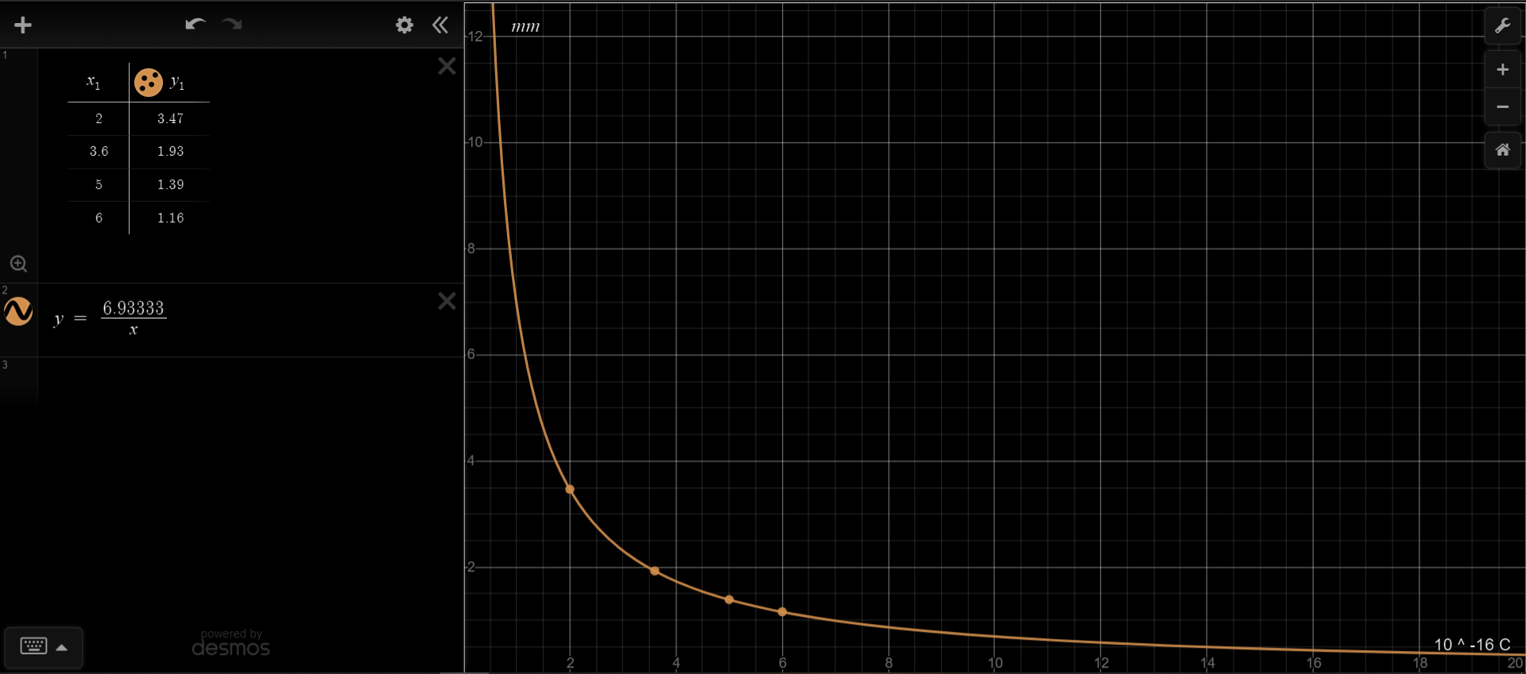

***Simulation 4*** -: Keeping the mass of the particle, perpendicular component of velocity and charge constant and varying the magnetic field.

**Snapshots** -:

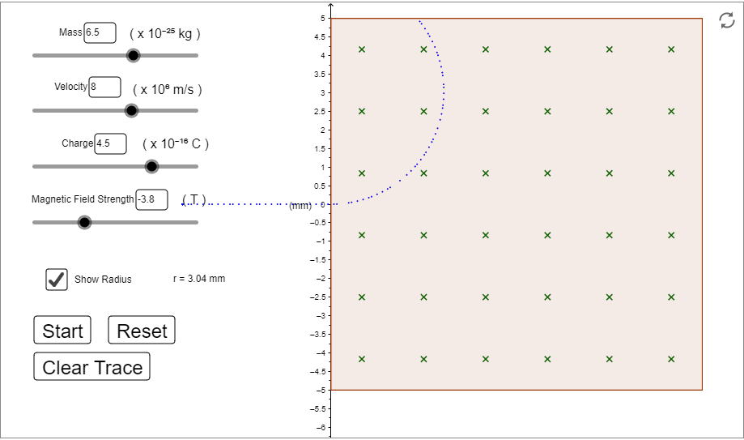

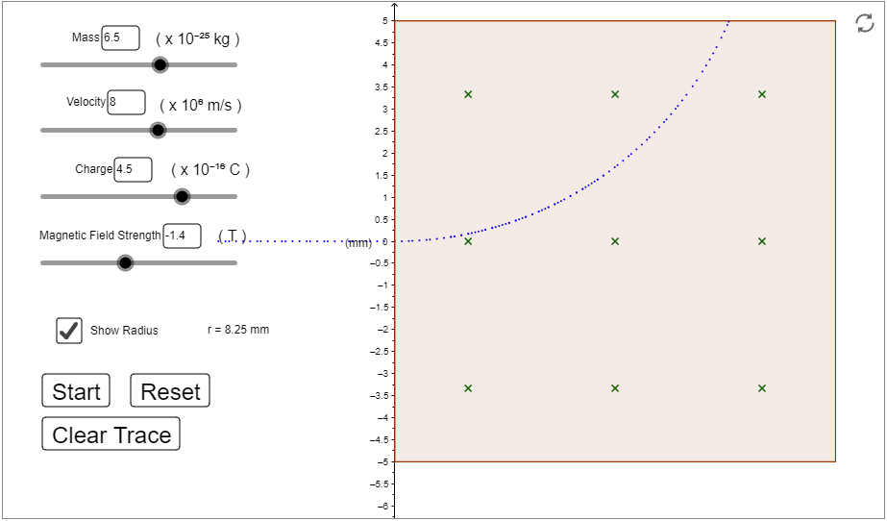

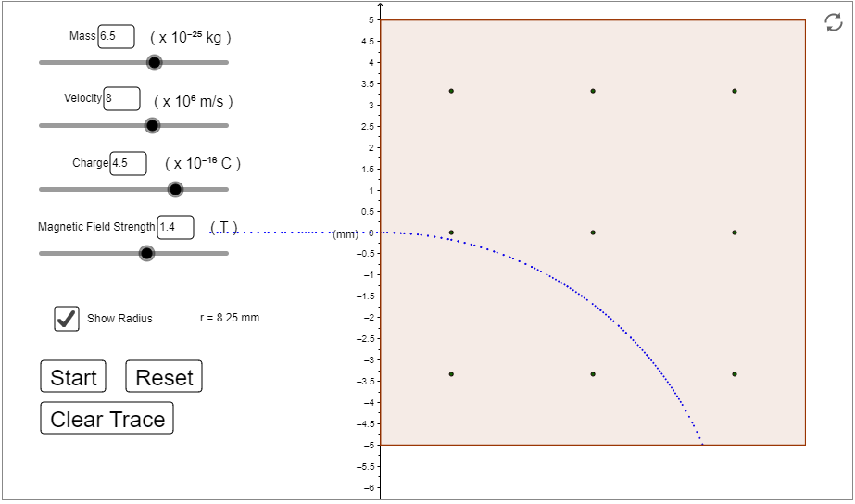

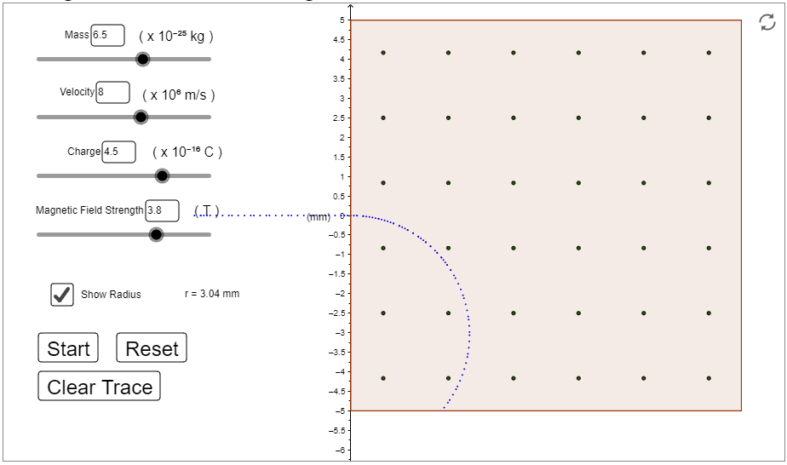

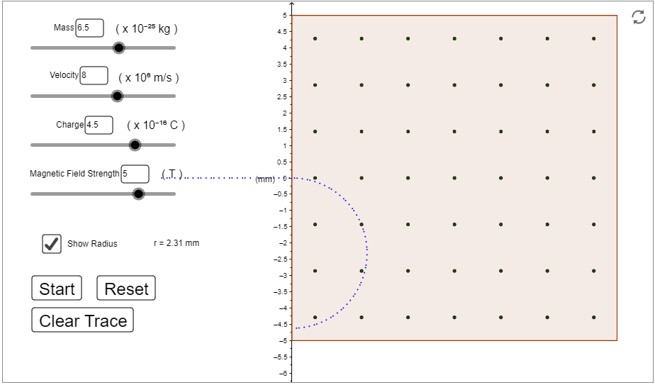

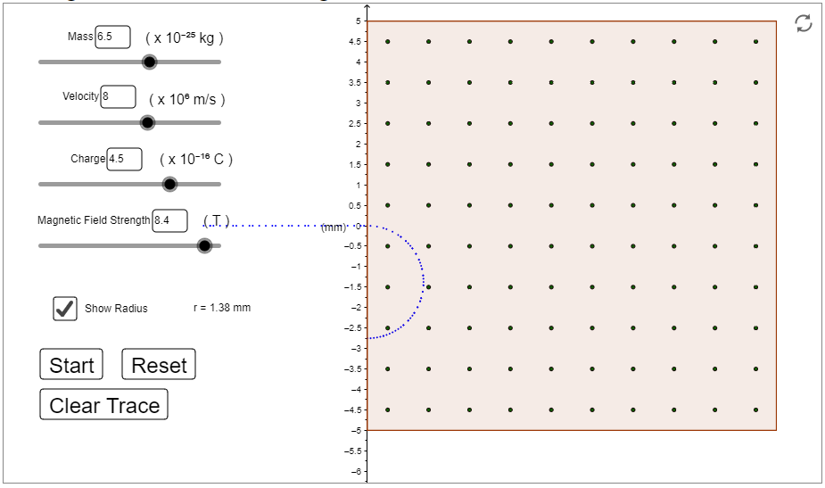

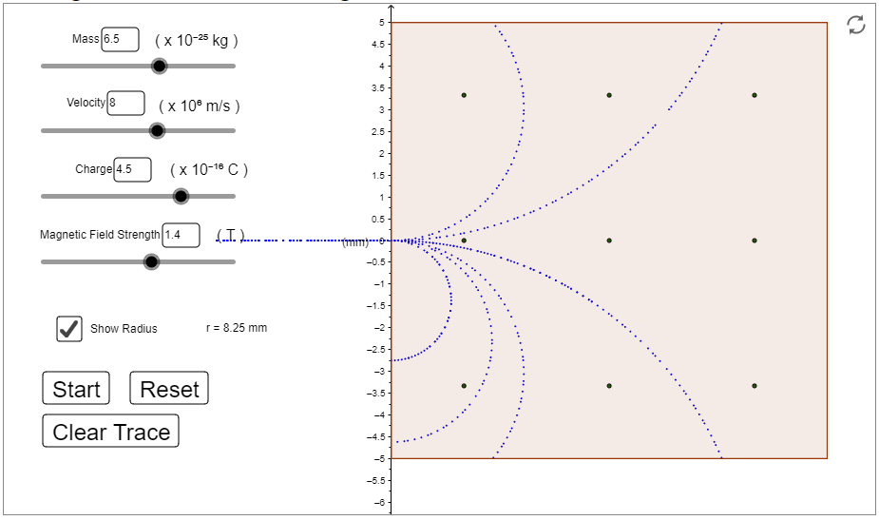

**Observation Table 4** -:

mass =

velocity =

charge =

|  |  |  |  |  |
| --- | --- | --- | --- | --- |
| **S.No.** | **Magnetic Field**  **(Tesla)** | **Radius**  **r =**  **(in mm)** | **Radius**  **observed**  **(in mm)** | **Time Period**  **(in nanoseconds)** |
| **1.** | -3.8 | 3.041 | 3.04 | 2.387 |
| **2.** | -1.4 | 8.254 | 8.25 | 6.479 |
| **3.** | 1.4 | 8.254 | 8.25 | 6.479 |
| **4.** | 3.8 | 3.041 | 3.04 | 2.387 |
| **5.** | 5.0 | 2.311 | 2.31 | 1.814 |
| **6.** | 8.4 | 1.376 | 1.38 | 1.080 |

**Graph of radius(r) vs magnetic field (B)** -:

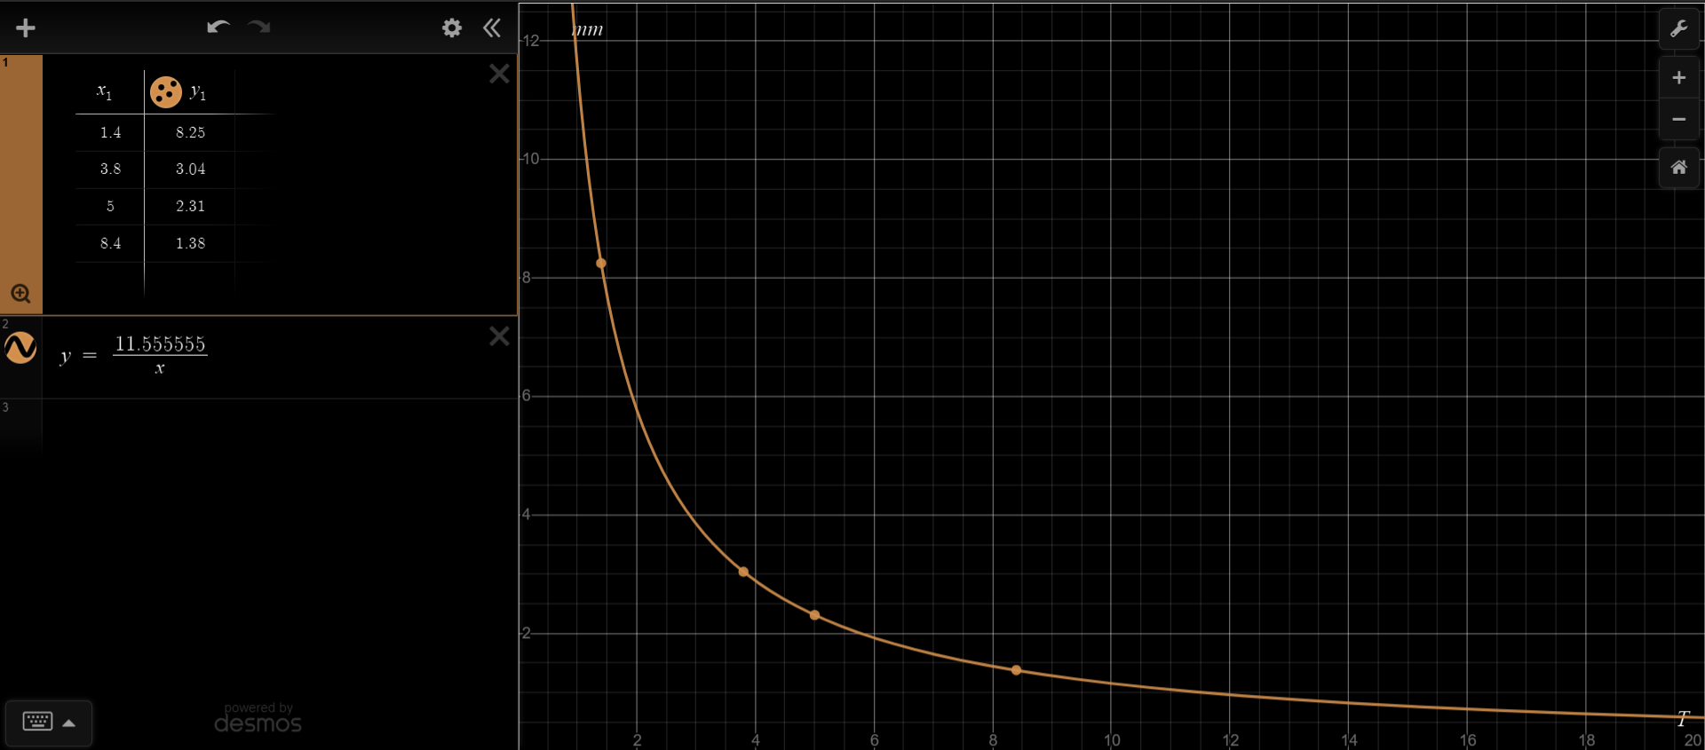

***Simulation 5*** -: Keeping the mass of the particle, perpendicular component of velocity, charge and the magnetic field constant and varying the parallel component of velocity().

**Snapshots** -:

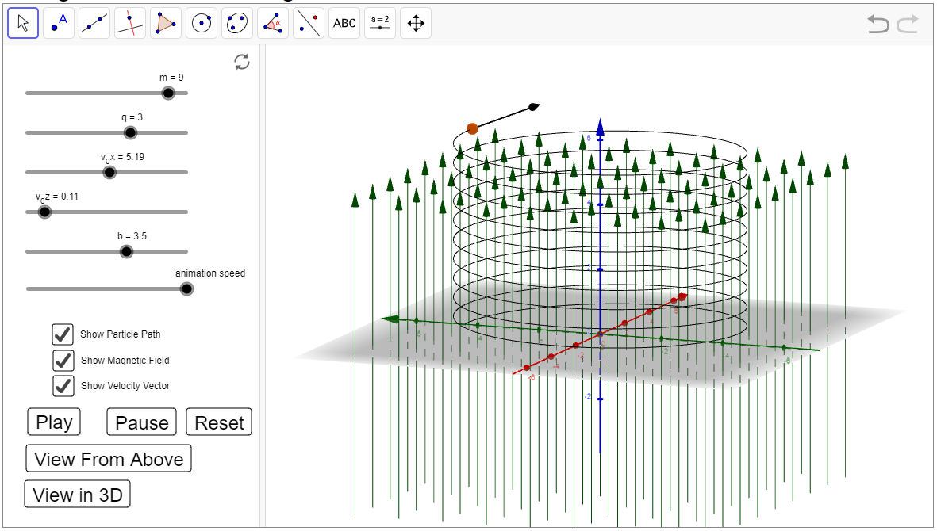

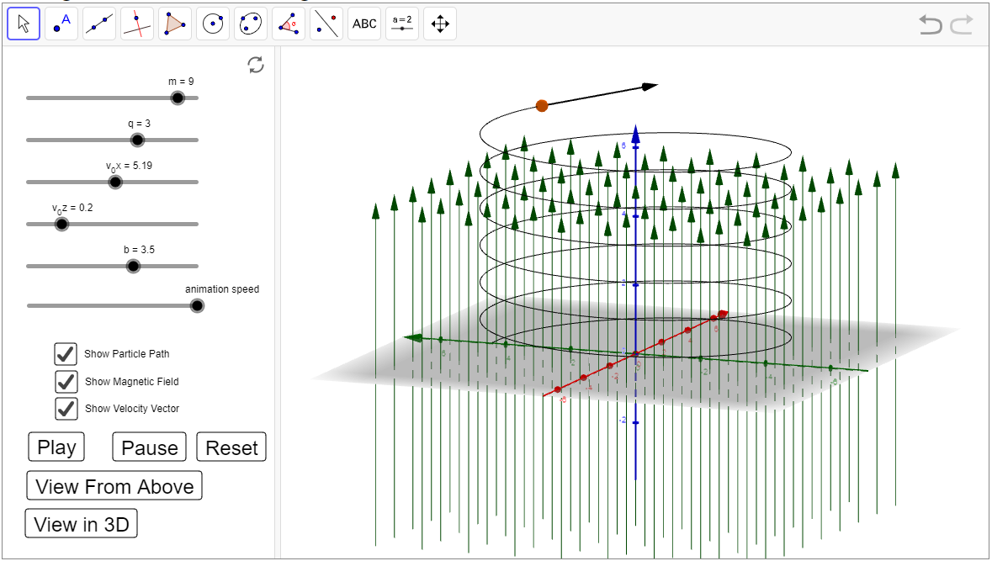

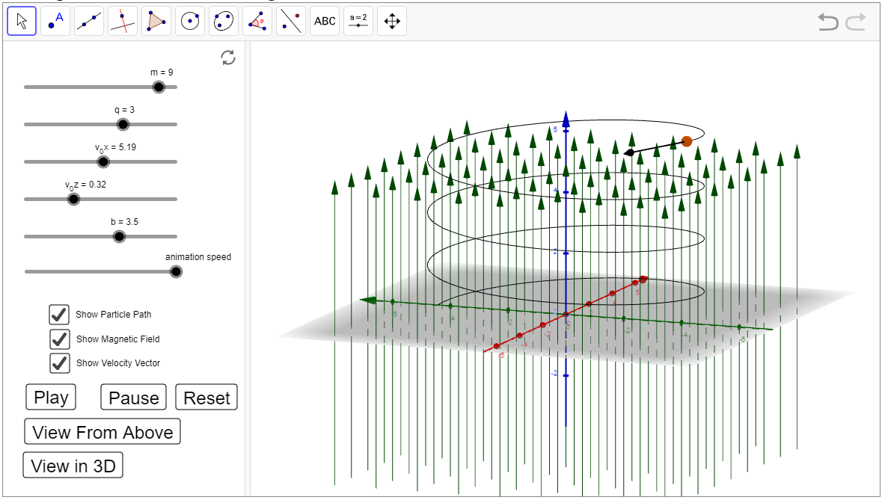

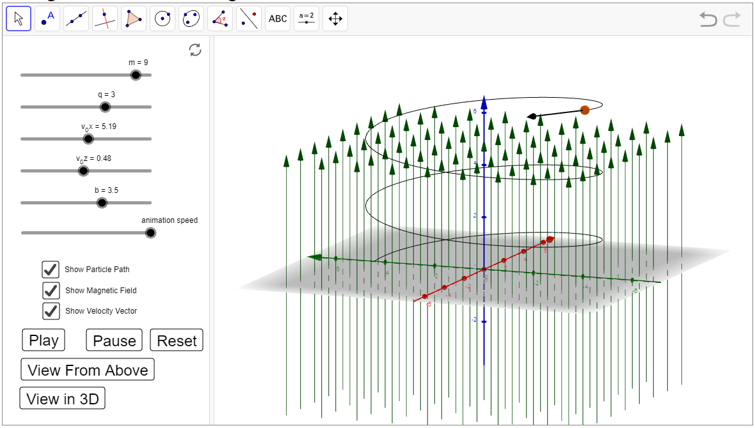

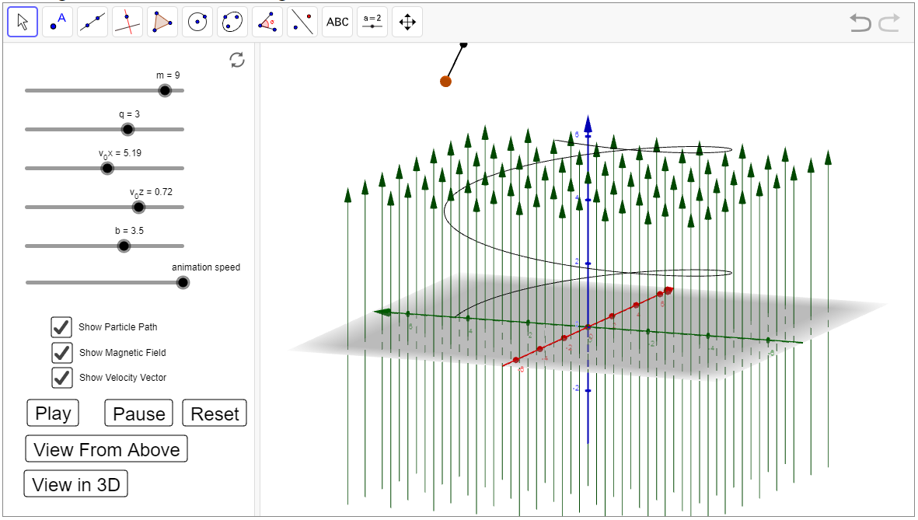

**Observation Table 5** -: Since the units are not explicitly mentioned in the simulator 2, the units are not written here also

mass =

perpendicular velocity =

charge =

magnetic field =

therefore, the radius of revolutions is r = =

r = 4.4486 units

and time period T =

T = 5.383 units

|  |  |  |  |  |
| --- | --- | --- | --- | --- |
| **S.No.** | **Radius**  **r =** | **Time Period** | **Parallel Component of Velocity** | **Pitch** |
| **1.** | 4.4486 | 5.383 | 0.11 | 0.592 |
| **2.** | 4.4486 | 5.383 | 0.20 | 1.077 |
| **3.** | 4.4486 | 5.383 | 0.32 | 1.723 |
| **4.** | 4.4486 | 5.383 | 0.48 | 2.584 |
| **5.** | 4.4486 | 5.383 | 0.72 | 3.876 |

**Graph of pitch(a) vs parallel component of velocity ()** -:

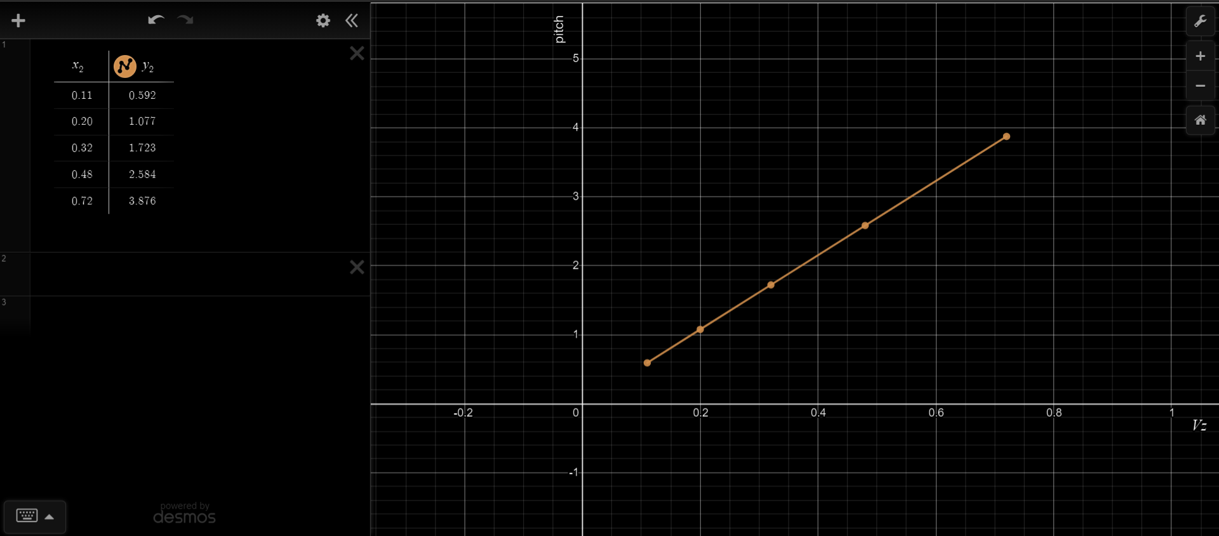

***Conclusions -:***

* The magnetic force on a charge particle is orthogonal to the magnetic field vector, and depends on the velocity of the particle. The right-hand rule can be used to determine the direction of the force.
* If a charged particle’s velocity is completely parallel to the magnetic field, the magnetic field will exert no force on the particle and thus the velocity will remain constant.
* In the case that the velocity vector is neither parallel nor perpendicular to the magnetic field, the component of the velocity parallel to the field will remain constant.
* The magnetic field does no work, so the kinetic energy and speed of a charged particle in a magnetic field remain constant. Circular motion results when the velocity of a charged particle is perpendicular to the magnetic field. The speed and kinetic energy of the particle remain constant, but the direction is altered at each instant by the perpendicular magnetic force.
* The magnetic force, acting perpendicular to the velocity of the particle, will cause circular motion.
* The centripetal force of the particle is provided by magnetic Lorentzian force so that
* Solving for r above yields the gryoradius, or the radius of curvature of the path of a particle with charge q and mass m moving in a magnetic field of strength B. The gryoradius is then given by .
* The cyclotron frequency (or, equivalently, gyrofrequency) is the number of cycles a particle completes around its circular circuit every second and is given by